Rapporteur: Hon. Mr. Karma Tenzin (Bhutan)

- The Ad-hoc Committee on APA Financial and staff Regulations held its meeting on 24 -25 June 2014 in Phnom Penh, Kingdom of Cambodia. APA Delegations from Bahrain, Bhutan, Cambodia, Iran, Jordan, Laos, Maldives, Pakistan, Russian Federation and Saudi Arabia participated. Representatives of Embassies of China, Indonesia, North Korea and Thailand also took part in the meeting. The list of participants is attached as Annex I.

- H.E. Mr. Leng Peng Long, Secretary-General of National Assembly of the Kingdom of Cambodia, H.E. Mr. Amir Hossein Zamaninia, APA Assistant Secretary-General, and H.E. Senator Mushahid Hussain Sayed, Representative of APA President (Pakistan) each made an opening statement. Texts of statements are attached as Annex II.

- H.E. Dr. NGUON NHEL, 1st Vice-President of National Assembly of Cambodia inaugurated the meeting. In his opening address he welcomed the delegates from APA member parliaments and wished them a successful deliberation on APA Financial and Staff regulations. He emphasized on importance of APA as an Asian Parliamentary Organization and expressed the need for setting up its permanent financial and administrative regulations and requested all member parliaments to support the organization by all available means. He also encouraged the participants in this meeting to finalize these documents and refer them to the upcoming Executive Council meeting. Text of his speech is attached as Annex III.

The inaugural meeting was concluded at 10:20.

- The Ad-Hoc Committee on Staff and Financial regulations was opened at 11:00 by Committee Chairman, H.E Mr. Nhem Thavy, MP (Cambodia).
- The Chair moved to adopt the draft agenda. It was adopted. It is attached as Annex IV.
- The meeting elected Honorable Dr. Said A. Al-Shaikh, member of Majlis Ash Shura of the Kingdom of Saudi Arabia as Vice – Chairman and Honorable Mr. Karma Tenzin, Member of Parliament of Bhutan as the rapporteur.

- H.E. Mr. Zamaninia, APA Assistant Secretary-General presented the Report of APA Secretary-General contained in document SG/Rep/2014/3 of 14 June 2014. He briefed the meeting on the background of Financial and Staff regulations. He also highlighted the major issues in the regulations which required greater attention of the delegates.
- The meeting deliberated on various provisions of the APA draft Financial Regulations. The scale of assessment of contribution drew great interests from all participating delegations. A serious discussion pursued; several amendments and several formulas were discussed. The meeting decided that without prejudice to adoption of the Financial Regulations, the scale of assessment requires further consideration and asked the Secretariat to continue to work, in coordination with APA Vice-President for Administrative and personnel regulations (Cambodia) on its formula. The meeting requested the Secretary-General to submit a further report on formula for determination of assessed contributions to the next meeting of the Executive Council. The Secretariat elaborated that at the initial phase, the Secretariat plants to have between 12-15 staff and estimated the annual budget to remain in the range of one Million US dollars for a number of years.

- In light of the paragraph above, it was decided to propose to the Executive Council to consider recommending the adoption of the draft Financial Regulations as amended.

- The meeting then turned to the next item: draft Staff Regulations. H.E. Mr. Zamaninia provided some background information on the subject and drew the attention of the delegates to major issues therein: the issue of secondments, and the proposed APA organizational chart.

- Many delegations sought clarifications on a number of issues and proposed amendments, including on the question of privileges and immunities, travels and air plane tickets, Health insurance, number of grades in each category of APA staff.

- All delegations agreed to propose to the Executive Council to recommend adoption of the draft Staff Regulations, with the understanding that delegations would submit their amendments well in advance of the Executive Council meeting so as to enable the Secretariat to submit the amended text of Staff Regulations to the Executive Council.

- The Ad-hoc Committee proposes the following draft resolution to the Executive Council for further consideration and recommendation for adoption at the Plenary.

We, the members of the Asian Parliamentary Assembly,

Taking note of APA/Res/2008/04 and other relevant APA documents;
Determined to enhance the efficiency and organizational capacity of the APA to achieve its goals and objectives enshrined in its Charter;
Confirming the importance of participation by all Member Parliaments in meeting the financial needs of the APA Secretariat;
- Take note with appreciation of the draft Financial and Staff regulations prepared by the Secretariat,

- Approve the Financial and Staff Regulations as amended and attached to this resolution,

- Decide to further consider the scale of assessed contribution by member parliaments to the general budget of APA Secretariat, and request the Secretary-General to prepare, in consultation with APA Vice-President for Financial and Administrative Affairs (Cambodia), a further report on formula for determination of assessed contribution by member parliaments to APA annual budget,

- Recommend to all APA Member Parliaments, particularly those with stronger economies, pending implementation of these regulations, to make voluntary contributions and assign a professional staff as secondment to APA Secretariat in order to enhance its capacity to optimize the function entrusted to it by the Plenary,

- Appreciate the Islamic Parliament of Iran for payment of APA budget since its establishment, and request the Islamic Parliament of Iran, in light of Rule 40 of the Rules of Procedure, that pending the implementation of these Regulations and securing the regular payment of assessed contributions by Member Parliaments, to continue to provide financial support to the APA Secretariat,

- Request the Secretary-General to submit a proposed budget for 2015 fiscal year to the next Executive Council meeting.

Annex to the Draft Resolution proposed by Ad hoc Committee

APA
STAFF REGULATIONS

DRAFT

This Staff Regulations draft has 15 Chapters, 78 articles and 5 annexes. It is to be approved by the APA Executive Council for point of reference and implementation.

INDEX
CHAPTER-I: Scope and Definitions
CHAPTER-Il: Duties and Privileges
CHAPTER-Ill: Posts Classification
CHAPTER-IV: Appointments
CHAPTER-V: Interim Assignment and Secondment
CHAPTER-VI: Promotion
CHAPTER-VIl: Performance Reports
CHAPTER-VIll: Salaries, Increments, Allowances and other Financial Provisions
CHAPTER-IX: Official Holidays and Annual leaves
CHAPTER-X: Travel
CHAPTER-Xl: Health Care
CHAPTER-Xll: Disciplinary Measures
CHAPTER-XIIl: Termination of Service
CHAPTER-XIV: Legal and Administrative Structure of the Secretariat
CHAPTER-XV: Miscellaneous Provisions
ANNEXES
ANNEX-I: Scale of Monthly Salaries
ANNEX-Il: Qualification Rules
ANNEX-Ill: Transportation Allowance
ANNEX-IV: Daily Subsistence Allowance on Official Missions
ANNEX-V: Organizational Chart of the APA

CHAPTER I
SCOPE AND DEFINITIONS

CHAPTER - I
SCOPE AND DEFINITIONS

ARTICLE-I SCOPE
The present regulations shall be called "Staff Regulations of the Asian Parliamentary Assembly (APA), and shall be applicable to the staff of the APA Secretariat.

ARTICLE-2 DEFINITIONS AND TERMS OF REFRENCE
In this statute the following terms shall have the meaning hereunder assigned to them:

2.1 APA:
Asian Parliamentary Assembly.

2.2 Executive Council:
Executive Council of the APA as stipulated in the Charter and the Rules of Procedure.

2.3 Charter:
The Charter of the APA

2.4 Secretariat:
The Secretariat of the APA

2.5 Secretary General:
The Secretary General of the APA

2.6 Post:
A position within the organizational chart of the APA, approved in the budget of the Secretariat which entails a set of duties and responsibilities assigned to a staff member.

2.7 Staff Member:
An individual holding a permanent or temporary post in the Secretariat. Staff members are classified into professional and general categories.

2.8 Family of Staff Member:
Spouse, and up to three under 18 years of age children.

2.9 Country of Origin:
The State of which the staff member is a national.

2.10 Headquarters:
The seat of the APA Secretariat in Tehran, Capital of the Islamic Republic of Iran.

CHAPTER Il
DUTIES AND PRIVILEGES

CHAPTER-Il
DUTIES AND PRIVILEGES

ARTICLE- 3
APA is an Asian inter-parliamentary Assembly and the staff members of the APA Secretariat are international civil servants. In the exercise of their functions, they shall commit themselves to serving the interest of the APA and to conducting themselves with integrity and impartiality.

ARTICLE- 4
The staff members of the Secretariat shall carry out every aspect of their functions responsibly and in accordance with principles and objectives of APA Charter.

ARTICLE-5
In the discharge of their duties, the Secretary General and the Staff Members shall:

5.1 Put the interest of the APA above all other interests and perform their duties with integrity and impartiality.

5.2 Strictly abide by the provisions of the present and other relevant regulations.

5.3 Be courteous and promote a spirit of cooperation and professionalism in the Secretariat to ensure high performance.

5.4 Protecting the APA funds, properties and documents.

ARTICLE- 6
The Secretary General and Staff Members shall not:

6.1 Receive or seek instructions from anybody outside the APA.

6.2 Divulge any information acquired in the performance of their duties that are classified, either by its very nature or due to relevant instructions.

6.3 Keep for personal use any classified document of the APA.
6.4 Engage in any activity incompatible with the APA principles and objectives.

6.5 Engage in any other paid-for jobs, save in such exceptional cases as may be authorized by the Secretary General.

    - Behave in any way that may be detrimental to their posts and status as international civil servants.
ARTICLE -7
7.1 Staff Members shall secure the approval of Secretary General prior to making any public representation of the APA and/or Secretariat.

7.2 Staff Members shall accept rewards, grants or decorations from outside the APA with approval of the Secretary General.

ARTICLE -8
In the exercise of their duties, the professional staff members of the APA shall enjoy diplomatic privileges and immunities in accordance with the headquarters agreement, and relevant principles of international law.

ARTICLE -9
The diplomatic privileges and immunities shall be granted to the professional staff members in the interest of the APA and for accomplishment of the tasks assigned to them. They in no way may dispense the professional staff members from discharging their obligations or failure to abide by the local laws and regulations.

ARTICLE -10
10.1 Secretary General is the Head of APA Secretariat and, is accountable to the Plenary and the Executive Council for the conduct of the Secretariat and the implementation of the provisions of the present regulations.

10.2 All staff members are responsible to the Secretary General in discharging their functions and the duties assigned to them.

10.3 Based on procedures delineated in the Headquarters Agreement, the Secretary General shall decide to lift the immunity of any staff member.

CHAPTER III
POSTS CLASSIFICATION

CHAPTER - III
POSTS CLASSIFICATION
ARTICLE- 11
11.1 The Secretariat may create posts and thoroughly define their job descriptions and tasks in accordance with the provisions of the present Regulations and upon consideration in the APA Executive Council and approval of the Plenary.

11.2 Subject to Rule 45 of the APA Rules of Procedure, type of work and responsibilities of the APA personnel shall be divided into the following categories:

A- Professional staff:

- Assistants Secretary General
- Advisors
3. Directors
4. Experts (seniors – juniors)

B- General staff:

5. General staff

11.3 Each category shall be sub-divided into grades. The grades include posts that are similar in term of their degree of difficulty, required aptitude and ensuing duties and responsibilities, even where they differ in the nature of the activities involved. Each category comprises the following Grades, classified in the descending order:

1. Assistant Secretary General Category Grades A1, A2
2. Advisors of Secretary General Grades B1, B2,
3. Director Category Grades C1, C2
4. Experts Category Grades D1, D2,
5. General Staff Category Grades E1, E2,

11.4 Each category may allow a number of increments not exceeding one per year and not less than one every three years.*

* Remunerations relating to each Category are specified in Annex I.

ARTICLE- 12
Job descriptions of the various posts shall be defined by Secretary General.

12.1 Post and related financial category and salary according to the salary scale annexed to the present regulations (Annex 1).

12.2 The requisite qualifications, educational background and number of years of necessary related experience for having access to the said post in accordance with the Qualifications Rules annexed to these Regulations (Annex II).

CHAPTER IV
APPOINTMENT

CHAPTER- IV
APPOINTMENT

ARTICLE- 13 CONDITIONS OF APPOINTMENT
The Secretary General is elected in accordance with the provisions of the Rule 45 of Rules of Procedure.

ARTICLE- 14
The guidelines for appointing staff of the APA Secretariat are as follows:

14.1 Appointment of Assistants Secretary General and other professional staff shall be made by the secretary general, upon recommendation by a senior secretariat selection committee, taking into account, to the extent possible, equitable geographic distribution of the posts, and in accordance with the Qualification Rules set out in Annex II of the present regulation.

14.2 Appointment of professional staff shall be by designation for a four-year period, including the probationary period. After the initial term of four years, the contract may be renewed on yearly basis up to the sixth year to be counted from the date of joining the service.

14.3 Appointment of General Staff posts shall be made directly through local recruitment on a permanent basis.

ARTICLE-15
15.1 Appointment to a post shall be made only after the post has been created and for which necessary allocations have been provided for in the budget.

  - The APA Secretary General shall inform the Member Parliaments of vacant posts and their conditions in adequate time and shall invite them to submit their candidates.

15.3 In all cases, advertisements of vacant positions must include the conditions of appointment there to in accordance with the Qualifications Rules as attached to the present Regulations (Annex II).

ARTICLE- 16
In addition to the provisions contained in the preceding articles, an appointee to the APA must meet the following conditions:

16.1 To be twenty-five and not exceeding sixty-five years of age according to the Calendar in force in the country of origin.

16.2 Not having been convicted of a serious crime.

16.3 Not having been removed from any job for disciplinary reasons.

16.4 To be either nominated by their Parliament for posts subject to nomination or his/her Parliament should have no objection to their appointment in the APA Secretariat.

ARTICLE- 17
The Secretary General shall decide on the appointment of the staff members including terms and conditions governing the posts and their duties and obligations.

ARTICLE- 18
The date of commencement of the appointment of a staff member shall be deemed to be the date of his/her joining the duty. If he/she fails to report for duty without a legitimate reason, to be assessed by the Secretary General, within thirty days from the date of notification of his/her entry, the said appointment shall be considered null and void.

ARTICLE-19
The staff member who is granted permanent appointment shall undergo a probationary period of six months starting from the date of his/her joining. The Secretary General shall have the right to terminate his/her services during this period or upon its completion, if his/her aptitude for the post is not confirmed.

ARTICLE-20
In Case of change in his/her educational, social and professional status, the staff member must submit the relevant statements and documents within 30 days from the occurrence of such changes.

CHAPTER V
INTERIM ASSIGNMENT
AND SECONDMENT

CHAPTER- V
INTERIM ASSIGNMENT AND SECONDMENT

ARTICLE- 21 INTERIM ASSGINMENT
The Secretary General may, when necessary, assign a staff member on temporary basis and without compensation, to posts at the same or higher levels than those of his/her post within the same category provided that this shall not infringe upon the principle of promotion to vacant post.

ARTICLE- 22 SECONDMENTS
22.1 The Secretary General may approve the secondment of a staff member by an APA Member Parliament.

22.2 Secondment shall be for a maximum period of three years applicable to the staff member who has spent at least five years in service.

22.3 The post of a staff member shall remain vacant during the secondment period. The vacancy may however be filled, on a temporary basis.

22.4 The salary of a seconded staff member, travel expenses for himself/herself and his/her family members and all financial obligations, including the end of service indemnity, shall be borne by the party that seconded the staff.

CHAPTER VI
PROMOTION

CHAPTER -VI
PROMOTION
ARTICLE- 23
Promotion of a staff member shall be subject to the following:

23.1 Availability of a vacant post, in the next higher grade.

23.2 The staff member must have spent at least three years in his present grade.

23.3 The staff member must satisfy the qualification requirements for the post to which he/she is to be promoted.

23.4 The confirmation of the aptitude of the staff member for promotion shall be established by his/her obtaining a "very good" mark in the performance report for the preceding year and the average evaluation of his/her work in the reports for the other years in his/her present grade is at least "Good".

ARTICLE- 24
If the number of staff members eligible for promotion exceeds the number of vacant posts, preference shall be given to those with higher qualifications: the most senior in the service, the most highly educated and then the oldest.

ARTICLE- 25
On promotion, the staff member shall be entitled to the initial salary of the grade to which he/she is promoted. If his/her salary before promotion is higher than the initial salary of the grade to which he/she is promoted, he/she shall be entitled to the salary step immediately higher.

ARTICLE- 26
Promotion shall be effective from the date stated in the relevant decision.

CHAPTER VII
PERFORMANCE REPORTS

CHAPTER VII
PERFORMANCE REPORTS
ARTICLE- 27
Except in case of the Secretary General, annual performance reports shall be prepared for all staff members, during the last two months of the fiscal year for which the report is made.

ARTICLE- 28
In preparing performance repots, the following procedure shall be observed:

28.1 The report shall be prepared by the immediate supervisor of the staff member and approved by the staff superior to the reporting staff.

28.2 The performance of a staff member will be evaluated in the report as Excellent, Very Good, Good, fair or weak.

28.3 A staff member obtaining the evaluation "weak" shall be notified of this in writing.

28.4 The performance reports shall be retained in the service file of staff members.

ARTICLE- 29
The APA Secretary General shall appoint a Committee to study the cases of those staff-members who obtain the rating of "Weak" in their reports. The decision of the Committee thereon shall be final.

CHAPTER VIII
SALARIES, INCREMENTS, ALLOWANCES AND
OTHER FINANCIAL PROVISIONS

CHAPTER - VIII
SALARIES, INCREMENTS, ALLOWANCES AND
OTHER FINANCIAL PROVISIONS

ARTICLE- 30 SALARIES
30.1 The staff member shall be entitled, upon appointment, to the initial step in the salary scale of the grade to which he/she is appointed.

30.2 The staff member may be appointed at a higher salary than the initial step in the salary scale if so justified by his/her qualifications and experience, but it should not exceed two increments in the same grade.
ARTICLE- 31
The staff member shall not be entitled to a salary for days he/she has not worked, unless otherwise stipulated in the present Regulations.

ARTICLE- 32
32.1 No amount may be withheld from the salary of a staff member except for payment of a debt confirmed either officially or by a final court decision, and the amount withheld shall not exceed one-fourth of the salary except for payment of alimony.

32.2 In the event of accumulated debts, priority shall be given to alimony.

ARTICLE- 33
33.1 If a staff member is suspended from duty pending investigation by the APA competent authority, he/she shall receive half pay during the period of suspension. If he/she is acquitted, his/her remaining entitlements, for the period of suspension, shall be disbursed to him/her. If however the case is dispensed in a manner other than dismissal, the APA Secretary General shall decide the amount to be disbursed to the staff member out of the remaining part of his/her entitlements.

33.2 A staff member held in temporary custody shall be deemed to be suspended from duty, and the provisions of the previous paragraph shall apply to him/her.

ARTICLE- 34 ANNUAL SALARY INCREMENT
A staff member shall be entitled to an annual salary increment upon completion of one year service in his/her grade of appointment, in accordance with the salary scales annexed to the present Regulations, provided that he/she does not receive a "weak" evaluation for his/her performance during that year.

ARTICLE- 35 FAMILY ALLOWANCES
A staff member, if married, shall receive a monthly family allowance of 100 EUROs and 50 EUROs for every child to a maximum of three children.

ARTICLE- 36 EDUCATION ALLOWANCE
A staff member shall be entitled to an education allowance for a maximum of three children regularly attending an educational establishment, subject to the following conditions:

36.1 The allowance shall cover the cost of the educational expenses not exceeding the amount of Euros 2,400.00 per child, per annum.

36.2 The allowance is paid up to the end of the children's High School studies

36.3 No allowance is due in case of children:

A- Attending Nursery.
B- Pursuing studies by correspondence.
C- Enrolled for a Vocational Training Course for an Apprenticeship of less than one year.
D- Pursuing special courses.
E- Repetition due to repeated failure in the same grade.

36.4 No allowance is to be paid for:

A- Children over fourteen years of age who are still attending a primary school.
B- Children over eighteen years of age still attending secondary school.

36.5 The payment of allowance is subject to presentation of supporting documents.

ARTICLE- 37 INSTALLATION GRANT
Except for the Secretary General, any non-local official freshly appointed to a post shall receive, for once only, an installation allowance equivalent to two months of his/her basic salary.

ARTICLE- 38 TRANSPORT ALLOWANCE

38.1 The Secretary General shall be provided with a car and a driver for official and private use, in accordance with the relevant financial rules in force.

38.2 All other staff members shall be entitled to a monthly transport allowance, at the rates fixed in the schedule annexed hereto. (Annex III)

ARTICLE- 39 HOUSING ALLOWANCE
39.1 The Secretary General shall be entitled to a furnished residence and service staff, not dissimilar to the average residence of an Ambassador accredited to the host country.

39.2 Assistant Secretary General, Advisors, and Directors shall be entitled to a monthly housing allowance of 35 percent of the basic salary.

39.3 Other professional staff shall be entitled to a monthly housing allowance equivalent to 25% of the basic salary. Non local General Staff members shall be entitled to a monthly Housing Allowance equivalent to 25% of their basic salary.

ARTICLE- 40 OVERTIME
40.I The Secretary General may, assign work, outside the official working hours, to staff members to accomplish urgent tasks that cannot be completed during office hours. The number of those staff members must be kept to a strict minimum.

40.2 Compensation for such overtime work shall be computed on the basis of one hour and a half for each hour put in during normal working days, and two hours for each hour, put in during official holidays. No overtime compensation shall be paid in addition to travel allowance during official missions.

40.3 Compensation for overtime work in a given month shall not exceed 25% of the monthly basic salary. The APA Secretary General may, however, in limited and extreme cases of necessity, increase such compensation to a maximum of 50% of the basic monthly salary.

ARTICLE- 41 BONUSES
The Secretary General may grant once for good, an encouragement bonus up to two months of basic salary or an exceptional scale increase to a staff member having put in service or having done research of value or having submitted concrete proposals leading to the improvement of the working procedures, efficiency or rationalizing expenses. However, the number of recipients may not exceed 5% of the staffs of the concerned level. The annual cost of these allocations shall be included in the budget and submitted to the Executive Council for consideration and appropriate recommendation to the Plenary.

ARTICLE- 42
At the time of termination of the service of official staff members with a minimum of 2 years period of the tenure in the secretariat shall be paid as "End of service Gratuity" an amount equivalent to 15 days last salary and allowances (excluding housing allowances) for every completed year of satisfactory service subject to a maximum of six years. This will be applicable to all, from secretary general to the lowest level of staff. No end of service gratuity shall be paid in case of termination of service of a staff member on disciplinary grounds.

ARTICLE- 43
All local General staff members shall be covered by an appropriate Social Security or Pension Scheme of the host country providing them health care and retirement benefits applicable to the nationals of the host government.

CHAPTER IX
OFFICIAL HOLIDAYS
AND ANNUAL LEAVE

CHAPTER -IX
OFFICIAL HOLIDAYS AND ANNUAL LEAVE

ARTICLE- 44 OFFICIAL HOLIDAYS
The official national holidays of the host country and the anniversary day of the establishment of the APA (14 November) shall be considered official holidays for the staff members of the APA Secretariat.

ARTICLE- 45 ANNUAL LEAVE
45.1 Staff members shall be entitled to an annual leave of 30 working days with full salary.

45.2 Staff members shall not be entitled to annual leave before completing six months of service.

45.3 Leave dates shall be determined by reconciling the desire of the staff member and exigencies of duty.

45.4 A staff member shall not be entitled to accumulate his/her ordinary leave for more than two years including the current one. In the event the stipulated annual leave of a staff member is not approved because of the exigencies of work, he/she shall be given the choice of either accumulating it or getting financial compensation for it. Such compensation shall be calculated on the basis of staff-member's basic salary.

ARTICLE- 46 EMERGENCY LEAVE
Staff members shall be entitled to emergency leave with full pay in the following cases:

46.1 Staff members may, with the approval of the APA Secretary General, be granted emergency leave provided that such leave shall not exceed a total of 7 days per annum and 2 days each time.

46.2 Staff members shall be granted special leave, of not more than ten days, in the event of the death of a relative of the first or second degree.

46.3 Staff members shall be granted special leave up to one month when called up, in emergency situation, for military service, in his/her country. In case it exceeds one month, it shall be without salary.

ARTICLE- 47 SICK LEAVE
47.1 Staff members may be granted sick leave on condition that he/she produces a medical report to the effect that the staff member is unable to perform his/her duties, stating the nature of the illness and the probable duration of incapacity.

47.2 Staff members are entitled to their entire monthly salary, if this absence does not exceed 60 days. In case the period of absence exceeds this limit, the official is entitled for half of his monthly salary for the second additional period equal to the maximum of 60 days. If his/her absence exceeds the total of 120 days, the staff member can go on a further period of leave of 30 days without pay after the approval of the APA Secretary General.

47.3 In the event of continued illness, the staff member shall be referred to an approved medical committee to advise the Secretary General about the extent he/she can continue to work.

ARTICLE- 48 MATERNITY LEAVE
A female APA staff member shall be entitled to a 40 day maternity leave with full pay, whose starting date shall be determined on the basis of an approved medical report.

CHAPTER X
TRAVEL

CHAPTER-X
TRAVEL

ARTICLE 49
The Secretary General and his spouse shall travel first class .Children of the Secretary General and professional staff of the secretariat and their families shall travel business class. General Staff and members of their families shall travel economy class.

ARTICLE 50 TRAVELS ON APPOINTMENT AND TERMINATION OF SERVICE
Upon appointment of a staff member to a permanent post, with the exception of those belonging to the General Staff, the APA shall pay travel expenses plus 50 kilos of accompanied baggage for him and 30 kilos for his wife and 10 kilos for each child up to a maximum of three children by air, from his home country or country of residence to his place of duty. Upon termination of service, similar passage shall be provided.

50.1 The Secretary General may send staff members on official missions both within and outside the Headquarters country. The number of delegates in such official missions shall be kept to the bear minimum within the limits of the funds allocated for this purpose.

50.2 Upon appointment of a staff member to a permanent post, with the exception of those belonging to the General Staff, the APA shall pay travel expenses plus 50 kilos of accompanied baggage for him and 30 kilos for his wife and 10 kilos for each child up to a maximum of three children by air, from his home country or country of residence to his place of duty. Upon termination of service, similar passage shall be provided.

CHAPTER XI
HEALTH CARE

CHAPTER- XI
HEALTH CARE

ARTICLE-51
The APA shall provide for health care services by providing life and health insurance of:
51.1 All staff members, their spouses, and up to 3 unmarried children under 18 years of age.

51.2 The staff members residing overseas by virtue of their work and their families residing with them.

51.3 The staff members sent on official missions outside the Headquarters' country as well as the officials on authorized leave with their families.

ARTICLE-52
The health insurance shall bear 90% of all medical expenses incurred with the exception of the following unless the illness was caused by or during the service:

a- Eye glasses and contact lens
b- Hearing aids
c- False teeth, installation of dentures, cleaning of teeth
d- Plastic surgery.
e- Elimination of earlier permanent bodily defect
f- Cost of escorts at hospitals
g- Unauthorized regular check-ups
h- Any other expenses not relating to the treatment.

ARTICLE- 53
A staff member shall be under obligation to reimburse the expenses paid for treatment in case of established abuse by him, of the rights prescribed in the present Regulations in addition to the disciplinary measures stipulated in the present Regulations.

ARTICLE- 54
The health insurance shall bear the expenses of treatment of the staff member in the service of the APA if he/she incurred illness or injury - in such cases the treatment of the staff member shall continue until complete recovery even if the period involved extends beyond the end of service of the staff member in the APA .Such treatment shall not interfere with the right of a staff member to receive other benefits as stipulated in other Articles of present Regulations.

ARTICLE- 55
55.1 If a staff member during the service and because of it incurred illness or injury resulting in disability which does not seriously affect the level of his performance, the APA shall pay a suitable compensation to the staff member after a Medical Advisory Committee composed of three doctors accredited to the APA, examines the staff member for assessment of the degree of disability.

55.2 The amount of suitable compensation shall be determined with the approval of the Executive Council.

ARTICLE- 56
56.1 If the illness or injury is incurred during the tenure of service and because of it results in total disability or death, the APA shall pay a compensation to the staff member or his heirs equivalent to five percent of the total salaries received by the staff member during his period of service in the Secretariat with a minimum amount of Ten thousand EURO.

56.2 The payment of compensation in the event of total disability shall be made with the approval of the APA Executive Council after subjecting the disabled staff member to examination by a Medical Advisory Committee consisting of three doctors accredited to the APA for assessment of his degree of disability.
  - The above-mentioned compensation shall not adversely affect the right of a staff member to receive other benefits as provided for under other Articles of present Regulations.

CHAPTR XII
DISCIPLINARY MEASURES

CHAPTR-XII
DISCIPLINARY MEASURES
ARTICLE-57
57.1 The Secretary General shall take disciplinary action against a staff member who violates the present Regulations and rules of the APA and when the conduct of the staff member warrants such an action.

57.2 The disciplinary procedure shall be as follows:

a- A written notice by the immediate superior.
b- An initial written warning by the head above the immediate superior of the official.
c- Deduction from salary.
d- Decreasing the staff member's salary with the amount of his annual increment.
e- Final warning
f- Termination of service.

57.3 The Secretary General shall decide, according to the nature of the violation, which of the measures contained in paragraph d, e, and f should be taken as a disciplinary action.

ARTICLE-58
58.1 The Secretary General may initiate an investigation before giving a final written warning to the official concerned.

58.2 If a staff member behaves in a manner that may call for disciplinary action in accordance with the provisions of these Regulations and has already been deprived of the annual increment because of unsatisfactory performance report, the right to increment shall be withheld.

58.3 The APA Secretary General shall decide as to what appropriate action is to be taken when the implementation of measures related to increments is impossible because the staff member has already reached the ceiling.

ARTICLE- 59 DISCIPLINARY COMMITTEE
  - The Secretary General shall establish an ad-hoc disciplinary committee composed of a chairman and two members to study disciplinary cases referred to it under the terms of paragraph d, e, and f of Article 57.2 on condition that the ranks of the members of the committee shall not be lower than that of the official to be disciplined.
  - The Secretary General shall lay down the detailed provisions governing the conduct of the activities of the disciplinary committee.

CHAPTER XIII
TERMINATION OF SERVICE

CHAPTER - XIII
TERMINATION OF SERVICE

ARTICLE- 60
The services of a staff member shall be terminated for any one of the following reasons:

60.1 Abolition of the post.

60.2 Physical disability hindering the performance of job tasks upon a certified medical report.

60.3 Resignation.

60.4 Reaching the age of termination of service: Age 65

60.5 Death.

60.6 A decision by the Secretary General given on grounds other than disciplinary such as a "weak" grade in two consecutive or three inconsecutive performance reports.

60.7 Disciplinary dismissal.

60.8 Loss of any of the basic requirements for appointment.

ARTICLE-61
The decision to terminate the services of a staff member shall be issued by the APA Secretary General.

ARTICLE- 62
The abolition of a post shall be by a decision by the APA Executive Council upon a proposal of the Secretary General. The staff member concerned shall be given three months notice prior to the date set for abolition of the post.

ARTICLE-63
63.1 The application for resignation shall be addressed in writhing to the APA Secretary General through immediate superior of the staff member. The application shall state the desired effective date of the resignation with a notice period of not less than one month.

63.2 The APA Secretary General may accept or not accept the resignation within two months.

63.3 The staff member must continue to discharge his/her duties until the date fixed by the authority for the coming into effect of the resignation subject to the periods indicated above.

63.4 The resignation of a staff member suspended from duty or under investigation cannot be accepted until the case is decided upon.

63.5 A staff member shall be considered as having resigned in cases of unjustified absence from duty for an uninterrupted period of 15 days or a total of 30 inconsecutive days in one year.

63.6 A staff member shall be considered as having resigned at the date of the loss of any of the basic requirements of appointment stipulated during the service.

ARTICLE- 64
64.1 The service of a staff member shall be terminated when he completes sixty-five years of age. The appointing authority may, when the exigencies of the service so require, extend the service of a staff member beyond the age of sixty-five.

64.2 The period of additional service referred to in Article 65.1 can be extended upon a decision by the appointing authority for a maximum of two years, and such a period shall not be taken into account in the calculation of the termination indemnity.

ARTICLE- 65
Indemnity for end of service to be paid to the officials in the different cases shall be as follows:

65.1 In the cases of the expiry of the contract, abolition of post, certified physical disability, resignation, retirement and death, the staff member concerned shall be paid, for each year of service, an amount equal to the salary of two months. Payment in case of death shall be made to his legal heirs.

65.2 In the cases where the staff member is dismissed from service in accordance with the provisions of para 7 of Article 60, the staff member concerned shall be entitled to an end of service amounting to one-month salary for every year of his service.

ARTICLE- 66
66.1 A staff member shall be entitled to a termination indemnity as stipulated in Article 65 provided he/she has completed two or more years of service.

  - In the calculation of the termination indemnity, the fraction of a month of service shall be rounded up to a full month.

  - The termination indemnities stipulated in Article 65 of the present Regulations shall be calculated on the basis of the last monthly salary of the staff member concerned, excluding any of the allowances provided for under these Regulations.

CHAPTER XIV
LEGAL AND
ADMINISTRATIVE STRUCTURE OF
THE APA GENERAL SECRETARIAT

CHAPTER - XIV
LEGAL AND ADMINISTRATIVE STRUCTURE OF
THE APA GENERAL SECRETARIAT

ARTICLE-67
  - The Secretary General enjoys a legal personality. The Secretary General is the legal representative of the General Secretariat, and its official spokesman.

  - The administrative structure of the permanent Secretariat shall follow the hieratical organ gram shown in Annex-V. Gradual appointments of staff members shall be in consistence with the activities entrusted to the General Secretariat and within the allocated budget, as decided by the APA plenary. Employees shall be of high competence and within the least possible number.

CHAPTER XV
MISCELLANOUS
PROVISIONS

CHAPTER- XV
MISCELLANOUS PROVISIONS
ARTICLE- 68
The APA Secretary General, in accordance with the relevant rules, may conclude short-term contracts with nationals of Member Countries to carry out specific assignments of highly specialized nature in the event of extreme necessity and non-availability of qualified personnel within the APA. The Secretary General shall ensure that only persons with the requisite qualifications and expertise undertake such duties.
ARTICLE-69
69.1 The APA Secretary General may delegate some of his authority and powers to someone who he decides. The delegated person may as well delegate part of his authority to his immediate subordinates.
69.2 Any such delegation of powers shall be enacted by a decision specifying its duration and the responsibilities to be delegated. The decision shall be circulated to all the departments of the permanent Secretariat.
ARTICLE-70
The APA Permanent Secretariat shall fix the working days and office hours at the Secretariat, taking into account the working days and office hours in the host country.
ARTICLE- 71
The present Regulations shall come into force as of the date of their consideration by the executive council and, adoption by plenary. The decisions and instructions necessary for the implementation of the present Regulations shall be issued by the competent authorities.

ANNEX I
Secretariat Staff Salaries
SCALE OF SALARIES FOR THE APA PERSONNEL
(IN EURO)

TITLE | SALARY
SECRETARY GENERAL | EURO
Assistant Secretary General | EURO
Advisors | EURO
Directors | EURO
Experts | EURO
General Staff | EURO

TITLE | GRADE | SALARY
Assistant Secretary General | A1 | EURO
Assistant Secretary General | A2 | EURO
Advisors | B1 | EURO
Advisors | B2 | EURO
Directors | C1 | EURO
Directors | C2 | EURO
Experts | D1 | EURO
Experts | D2 | EURO
General Staff | E1 | EURO
General Staff | E2 | EURO

REMARKS: The APA Executive Council shall regularly review the scale of salaries for the APA Staff with a view to introducing the necessary amendments proposed by the Secretary General.
ANNEXE II
QUALIFICATION RULES

Any applicant to a post at the APA Secretariat must fulfill the following qualifications and years of experience (minimum)
GRADE CATEGORY | RELATED EXPERIENCE | FIELD OF EDUCATION | EDUCATION | TITLE
 | …….. |  | …… | Secretary General
A | …….. |  | …… | Assistant Secretary General
B | …….. |  | …… | Advisors
C | …….. |  | …… | Directors
D | …….. |  | …… | Experts
E |  |  |  | General Staff

ANNEX Ill
Monthly Transportation Allowance

CATEGORY | MONTHLY TRANSPORTATION ALLOWANCE
Assistants Secretary- General | ………
Advisors | ………
Directors | ………
Experts | ………
General Staff | ………

ANNEX IV
DAILY SUBSISTENCE ALLOWANCE ON
OFFICIAL MISSIONS

CATEGORY | Inside the  Host Country  (In EURO) | Outside the  Host Country  (In EURO)
SECRETARY GENERAL | .............. | ............
Assistant Secretary- General | ............. | ..........
Advisors | ................ | ...............
Directors | .............. | .............
Experts | ................ | ............
General Staff | ................ | ............

REMARKS:
1. If full board accommodation is provided by the host country or the APA, the Staff member receives 50% of the content of the above table.
2. In case the host Country or the APA provides local accommodation, Staff member receives 70% of the content of the above table.

ANNEXE V
APA TOP ORGANIGRAM
Number of future needed posts : 148
Number of present posts : 18

Secretary General
ASG. Political Affairs
ASG. Economic Affairs
ASG. Social and
Cultural Affairs
Chef De Cabinet
Public
Relation/Protocol
IT Officer
Documentation
SG ’Advisors
Accountant
Political Affairs Officer
Economic
Affairs Officer
Social and Cultural
Affairs Officer
Advisors
(MPs or Advisors proposed by APA Parliaments
Proposed by Russia)

APA
FINANCIAL REGULATIONS

DRAFT

DRAFT
APA FINANCIAL REGULATIONS

ARTICLE -1

The present Financial Regulations organize the financial administration of the APA. The Regulations shall become effective once they are considered by the Executive Council and adopted by the Plenary. It may only be amended through a decision of two third majority of Member Parliaments present and voting in the plenary.

ARTICLE -2

The fiscal year shall run from the first day of May to the last day of April.

ARTICLE -3

Secretary General⁭ shall prepare and present the draft annual budget to the Member Parliaments at least 30 days in advance of the first meeting of the Executive Council. The Council may establish a committee for further consideration of the draft to formulate its recommendations on the draft budget to the Executive Council. The final budget shall be adopted by the Plenary not later than the end of the fiscal year.

ARTICLE -4

Any replacement, decrease or increase in any chapter of the budget by the Secretary General shall be acceptable within a limit of 20% thereof. If need be for a higher increase, the Secretary General shall present an explanatory note for the consideration of the Executive Council. Any new chapter may also be added to the budget to cover the expenses relating to any new activity, in which case, detailed explanatory information shall be provided by the Secretary General to the Executive Council for consideration.

ARTICLE -5

The budget and the Secretariat accounts shall be drawn up and kept in Euro and Iranian Rial.

ARTICLE -6

Upon approval of the budget by the Plenary, the Secretary General shall be authorized to undertake financial commitments for the purposes for which credits have been approved within the limits of such credits in each chapter and item.

ARTICLE -7

All payments to the APA under any category, including voluntary contribution by Member parliaments, donations, grants, endowments, interests granted to funds and deposits shall be made in Euro and maintained in APA bank accounts, so as to facilitate its international auditing.

ARTICLE- 8

8.1. APA Secretary General may transfer credits between items in any one chapter up to 20% of the budget within the limits of the credit approved for the chapter concerned.

8.2 The Secretary General may transfer credits between chapters of the budget; up to 20 % whenever needed within the limits of the credits for each of the chapters.

8.3 All such transfers shall be reported in the explanatory information referred to in Article 4, together with an explanation of the circumstances.

ARTICLE -9

Credits shall be used for commitments only during the fiscal year to which they relate. In case of non-payment or delay of contributions, and in order to meet the level of budget by the APA, the Secretary General is allowed to use the funds available and adjust accordingly.

ARTICLE - 10

10.1 The budget approved by the Plenary shall be financed by contributions from Member Parliaments which will be assessed on the basis of a formula to be considered by the Executive Council and adopted by the Plenary.

10.2 Subject to the Rule 40 of the Rules of Procedure, once the Plenary has approved the annual budget, the Secretary General shall advise Member Parliaments of their assessed contribution and request them to remit the funds.

10.3 Contributions shall be considered due and payable in full, within 60 days of the receipt by Member Parliaments of Secretary General’s letter of assessment.

10.4. Non-payment of contributions by any Member Parliament shall be reported to the Executive Council for appropriate decision, which may include reporting it to the Plenary.

10.5 The Secretary General shall submit to the Executive Council a report on the collection of contributions.

ARTICLE – 11

11.1. The Secretary General shall be responsible for administering the APA funds.

11.2. The Secretary General shall set up those internal controls as may be necessary to maintain a continuous check on all financial transactions, ensure fitness and transparency, prevent any misapplication of funds, and ensure the utmost economy.

11.3 To this end, the Secretary General shall issue directives, set procedures and take the following steps:

11.3.1 To check that all expenditure is in conformity with the credits and other fiscal measures approved by the Plenary.

11.3.2 To ensure that payments are made only on production of vouchers for services rendered and/or goods received.

11.3.3 To sign and seal, together with Head of Human and Financial Resources Department, all operations of transfer of funds or cheques and financial liabilities, payment orders or any other documents pertaining to expenditure from the budget.

ARTICLE -12

APA funds shall be kept in Banks of the APA Headquarters.

ARTICLE -13

13.1 The Head of Human and Financial Resources Department shall maintain documents to show:
13.1.1. Amounts authorized, commitments undertaken, payments made, and available balances of authorizations with respect to each item in the budget.

13.1.2 Assessed contributions of all Member Parliaments, together with the payments received from them and the balances remaining due.

13.1.3 Miscellaneous income.

13.1.4 Cash balances and balances at banks.

13.1.5 Other assets and liabilities of the APA.
13.2 The Secretary General shall present to the Executive Council biannual financial reports on the APA financial situation.

ARTICLE -14
The Secretary General is authorized to write-off on losses of cash, stores and other assets up to limit of 1000 Euro and anything above this amount has to be approved by the Executive Council. A full statement of all such amounts written off shall be attached to the annual financial report.

ARTICLE -15

The APA funds shall be made up of:

- Payment of assessed contributions by Member Parliaments.
2- The grants, endowments and donations in cash and in kind accepted by the Secretary General⁭.
3- The Interests/profit granted on funds and deposits of the APA accounts.

ARTICLE -16

16.1 Upon the suggestion of Secretary General the Executive Council shall determine the fees of an External Account Auditor who shall be a certified accountant of the host country, locally appointed on a yearly basis by the Secretary General.

16.2 The local External Account Auditor shall present his/her report before the end of the fourth month of the next year to the Secretary General who shall submit it with his/her comments and views to the Financial Control Committee (FCC) , as defined by the paragraph 16.3 below, as well as to the Executive Council for consideration and approval.

16.3 A Financial Control Committee (FCC) composed of three Auditors shall be appointed by the Executive Council on a two-year rotational basis to be nominated by Member Parliaments from among those regularly contributing to the APA budget.

16.4 The Financial Control Committee (FCC) shall meet annually at the Headquarters of the Secretariat in order to audit the accounts of the Secretariat for the previous year and study the report made by the local External Auditor. The Committee shall present its report to the Executive Council through the Secretary General. This report shall include:

a) Remarks on financial matters.
b) Remarks on the report of the External Account Auditor.
c) The extent of effectiveness of the financial and internal control procedures within the Secretariat.

16.5 The local External Account Auditor shall abide by the conventional international rules and accounting standards.

16.6 In no case, however, shall the Financial Control Committee include substantial observations in its audit report without first affording the Secretary General or his/her representative(s) an opportunity for explanations to the FCC on the matter under observation. Such explanations shall be included in the report of the Committee.

16.7 The Secretary General may submit to the Executive Council a report giving his/her views and observations on the Report of the Financial Control Committee (FCC) and that of the local External Auditor.

16.8 The Secretary General shall pay the fees of the local External Account Auditor, while the fees and other expenses of the Financial Control Committee (FCC) shall be borne by their respective Parliaments.

16.9 No former staff member of the Secretariat shall be appointed as Auditor. Likewise, no former Auditor shall be appointed in the Secretariat before a period of three years has elapsed since he/she left his/her last position.

ARTICLE -17

The Executive Council shall examine the reports of the Financial Control Committee (FCC), of the local External Auditor and of the Secretary General. Approval of the Report of the Financial Control Committee (FCC) by the Executive Council shall authorize the closing of the accounts of the concerned fiscal year and clearing the Secretary General's financial responsibility thereon. Otherwise, the Executive Council shall continue to investigate the remaining questions and find resolution before the end of the next fiscal year.

Amendments proposed by Russian Federation on APA Staff regulations

CHAPTER-X
TRAVEL

ARTICLE 49 TRAVELS ON OFFICIAL MISSIONS

49.1.The Secretary General shall travel business class, and first class if the flight or flight connection lasts more than 4 hours only. Professional staff of the secretariat shall travel economy class and business class if the flight or flight connection lasts more than four hours only. General Staff shall travel economy class.

49.2 The Secretary General may send staff members on official missions both within and outside the Headquarters country. The number of delegates in such official missions shall be kept to the bear minimum within the limits of the funds allocated for this purpose.

ARTICLE 50 TRAVELS ON APPOINTMENT AND TERMINATION OF SERVICE

50.1. The Secretary General and his spouse shall travel business class, and first class if the flight or flight connection lasts more than 4 hours only. Children of the Secretary General and Professional staff of the secretariat and their families shall travel economy class and business class if the flight or flight connection lasts more than four hours only. General Staff and members of their families shall travel economy class.

Amendments proposed by Russian Federation on APA Financial regulations

ARTICLE - 10

10.1 The annual budget, which shall be approved by the Plenary and will not exceed 1,000,000 US dollars (one million US dollars), shall be financed by contributions from Member Parliaments which will be assessed on the basis of a formula to be considered by the Executive Council and adopted by the Plenary being an indispensable attachment of these Regulations

Formula for Budget Contribution

1-Based on APA Charter Article 8: Number of Votes
Population Between | allowed Number of Votes per country member
1 Millions – 50 Millions | 2+2 = 4
50 Millions – 200 Millions | 2+3= 5
200 Millions – 500 Millions | 2+4= 6
Over 500 Millions | 2+5=7

2-Based on GDP of each country members:
3-Cambodian Delegation suggests the following formula:
For country members with GDP:
a-Less than US$ 10,000 contribution is US$ 3,000/per voter
b-Between US$10,000 and US$20,000 contribution is US$4,000/per voter
c-More than US$20,000 contribution is US$5,000/per voter
Therefore,
Proposed Contribution is:
- Contribution = Votes x US$ 3,000 (for country with GDP Less than US$ 10,000)
- Contribution = Votes x US$ 4,000 (for country with GDP Between US$10,000 and US$20,000)
- Contribution = Votes x US$ 5,000 (for country with GDPMore than US$20,000)
Proposed Contribution by Each Country
COUNTRY | COUNTRY | GDP/ CAPITA | NUMBER | CONTRIBUTION | COUNTRY
NAME | POPULATION | PPP/IMF-2012 | OF VOTES | AS GDP | CONTRIBUTION
 |  |  |  | US$ | US$
Afgarnistan | 25,500,100 | 1,055 | 4 | 3,000.00 | $12,000
Bahrain | 1,248,348 | 28,691 | 4 | 5,000.00 | $20,000
Bangladesh | 156,507,000 | 1,963 | 5 | 3,000.00 | $15,000
Bhutan | 748,760 | 6,564 | 4 | 3,000.00 | $12,000
Cambodia | 15,184,116 | 2,395 | 4 | 3,000.00 | $12,000
China | 1,365,200,000 | 9,055 | 7 | 3,000.00 | $21,000
Cyprus | 865,878 | 26,794 | 4 | 5,000.00 | $20,000
India | 1,245,780,000 | 3,843 | 7 | 3,000.00 | $21,000
Indonesia | 247,424,698 | 4,923 | 6 | 3,000.00 | $18,000
Iran | 77,530,000 | 12,986 | 5 | 4,000.00 | $20,000
Iraq | 34,035,000 | 7,004 | 4 | 3,000.00 | $12,000
Jordan | 6,598,720 | 5,977 | 4 | 3,000.00 | $12,000
Kazakhstan | 17,244,000 | 13,526 | 4 | 4,000.00 | $16,000
Kiribati | 106,461 | 6,241 | 4 | 3,000.00 | $12,000
DPR Korea | 24,895,000 | 1,200 | 4 | 3,000.00 | $12,000
South Korea | 50,423,955 | 31,950 | 5 | 5,000.00 | $25,000
Kuwait | 3,605,850 | 39,874 | 4 | 5,000.00 | $20,000
Kyrgyzstan | 5,776,570 | 2,351 | 4 | 3,000.00 | $12,000
Laos | 6,580,800 | 2,847 | 4 | 3,000.00 | $12,000
Lebanon | 4,822,000 | 15,587 | 4 | 4,000.00 | $12,000
Malaysia | 30,166,000 | 16,794 | 4 | 4,000.00 | $16,000
Maldives | 317,280 | 8,856 | 4 | 3,000.00 | $12,000
Mongolia | 2,931,300 | 5,314 | 4 | 3,000.00 | $12,000
Nepal | 26,494,504 | 1,457 | 4 | 3,000.00 | $12,000
Pakistan | 188,020,000 | 3,056 | 5 | 3,000.00 | $15,000
Palau | 20,901 | 23,053 | 4 | 5,000.00 | $20,000
Palestinian Authority | 4,420,549 | N/A | 4 | 3,000.00 | $12,000
Philipines | 99,760,100 | 4,380 | 5 | 3,000.00 | $15,000
Russia | 146,000,000 | 17,518 | 5 | 4,000.00 | $20,000
Saudi Arabia | 29,994,272 | 30,477 | 4 | 5,000.00 | $20,000
Singapore | 5,399,200 | 60,799 | 4 | 5,000.00 | $20,000
Sri Lanka | 20,277,597 | 6,046 | 4 | 3,000.00 | $12,000
Syria | 21,898,000 | 2,188 | 4 | 3,000.00 | $12,000
Tajikistan | 8,160,000 | 2,205 | 4 | 3,000.00 | $12,000
Thailand | 64,456,700 | 9,503 | 5 | 3,000.00 | $15,000
Tonga | 103,036 | 7,987 | 4 | 3,000.00 | $12,000
Turkey | 76,667,864 | 14,812 | 5 | 4,000.00 | $20,000
United Arab Emirates | 9,346,000 | 29,176 | 4 | 5,000.00 | $20,000
Uzbekistan | 30,492,800 | 3,523 | 4 | 3,000.00 | $12,000
Vietnam | 89,708,900 | 3,788 | 5 | 3,000.00 | $15,000
Yemen | 25,235,000 | 2,251 | 4 | 3,000.00 | $12,000
Total |  |  |  |  | $632,000

For GDP /capita
Less than US$9,999 | country contribution US$3,000 / vote
Between US$10,000 to US$19,999 | country contribution US$4,000 / vote
Larger than US$20,000 | country contribution US$5,000 / vote

This calculation is based on the article 8 of APA charter and GDP per capita by country
Annex - I
List of Participants in the Ad-hoc committee on Financial Regulations

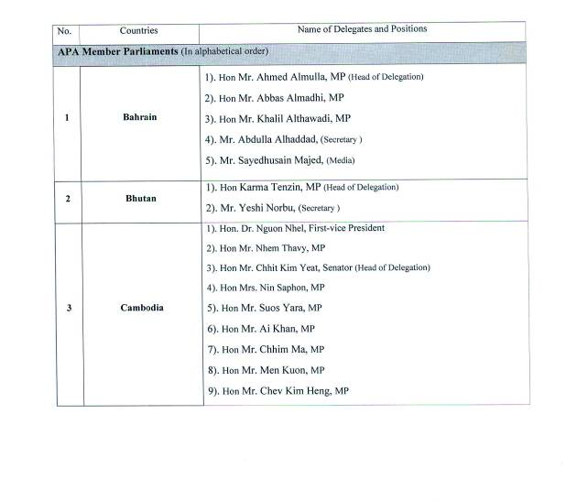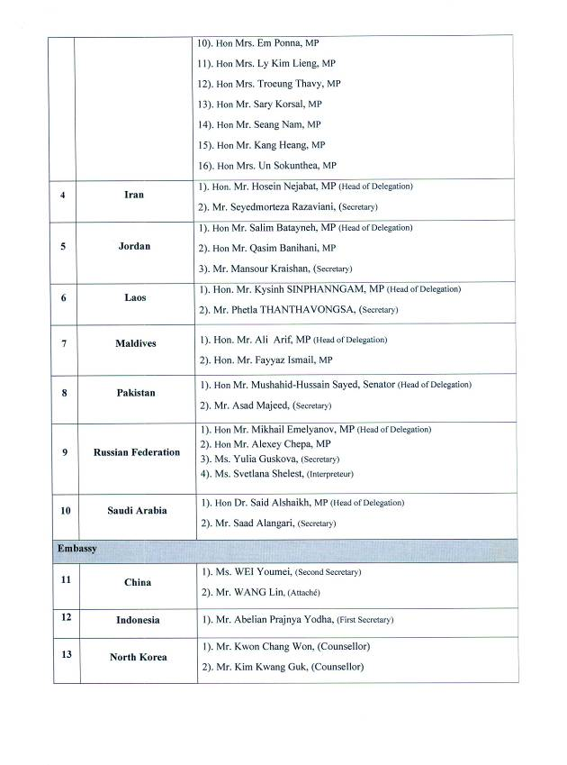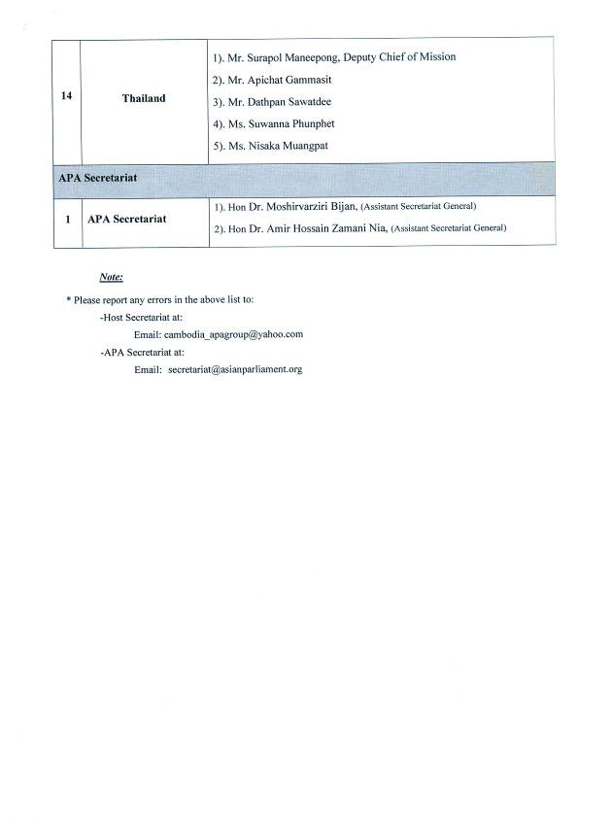
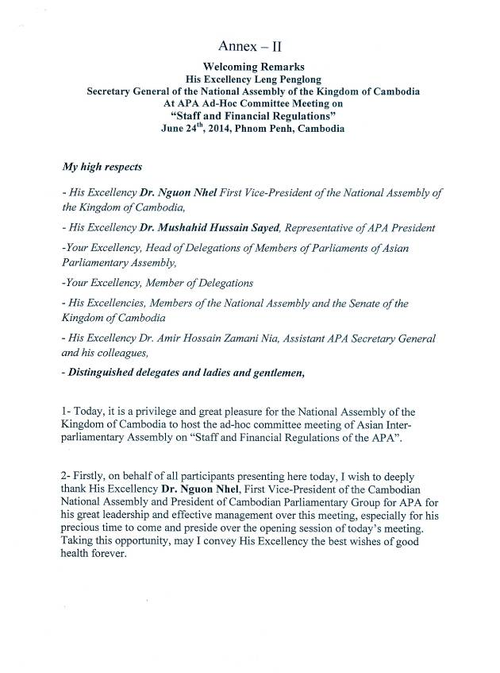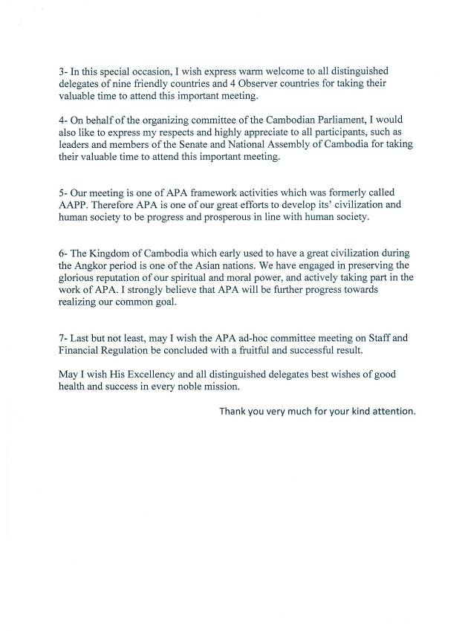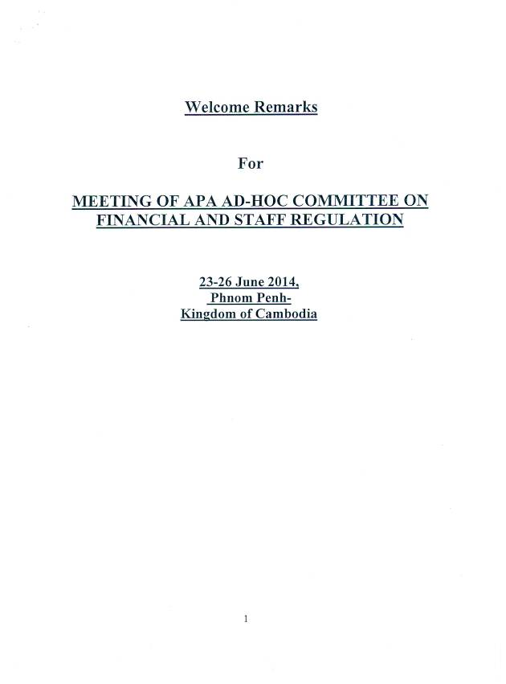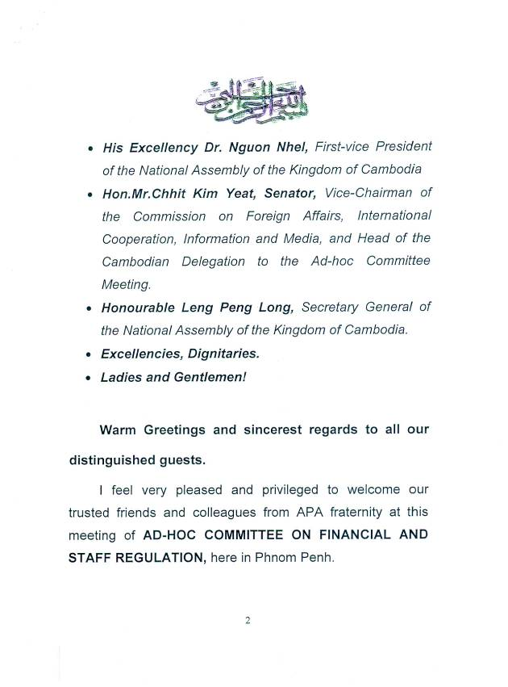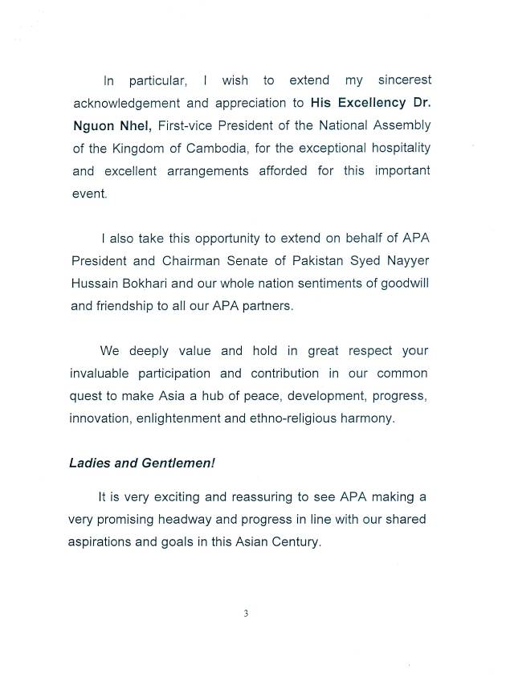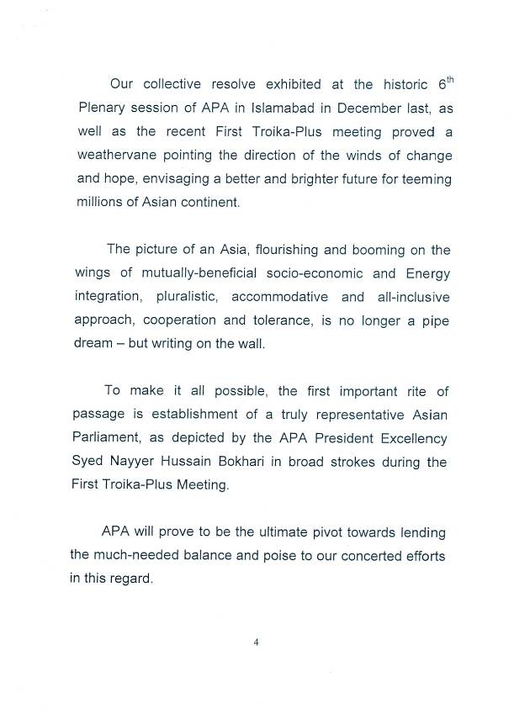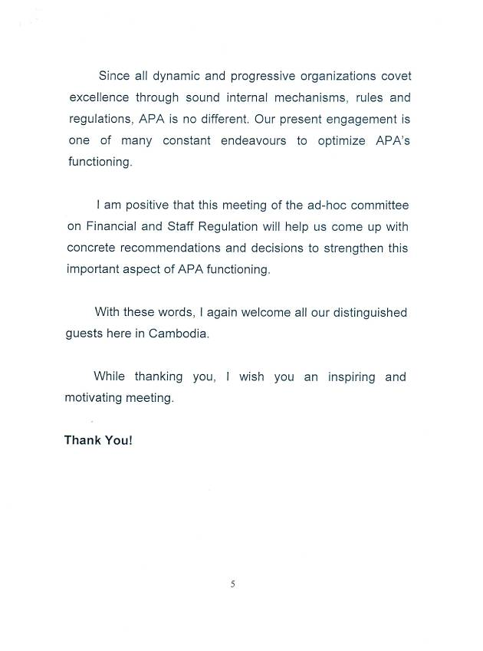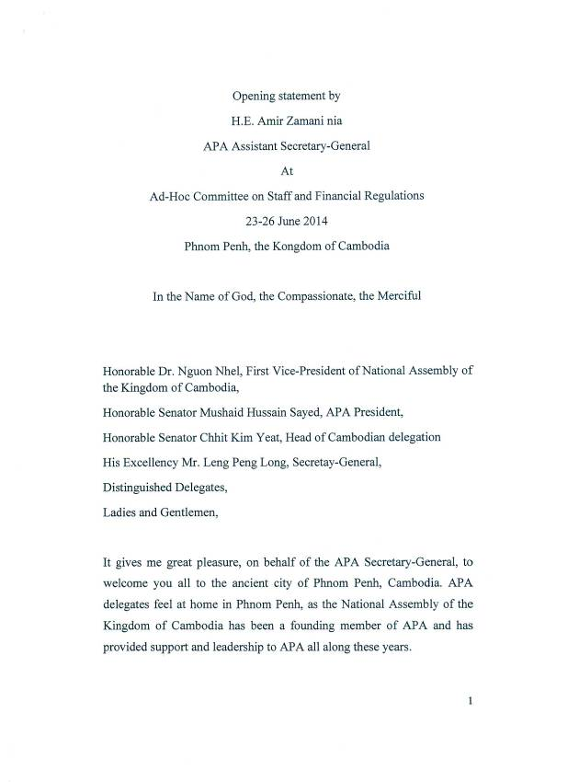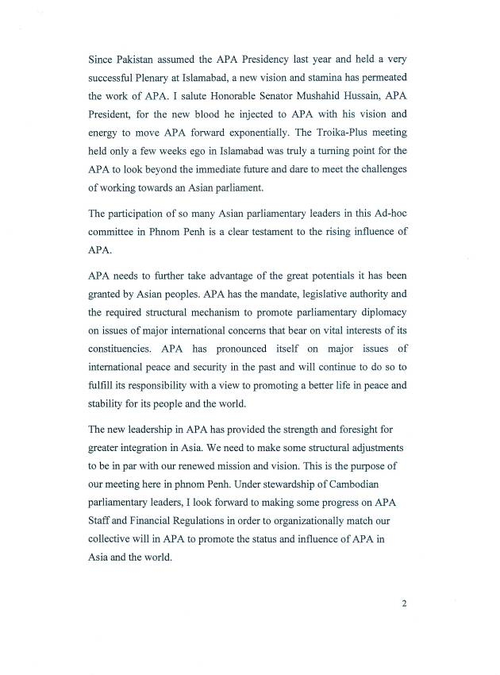
Annex – III
Text of Speech of H.E. Dr. NGUON NHEL, 1st Vice-President of National Assembly of Cambodia
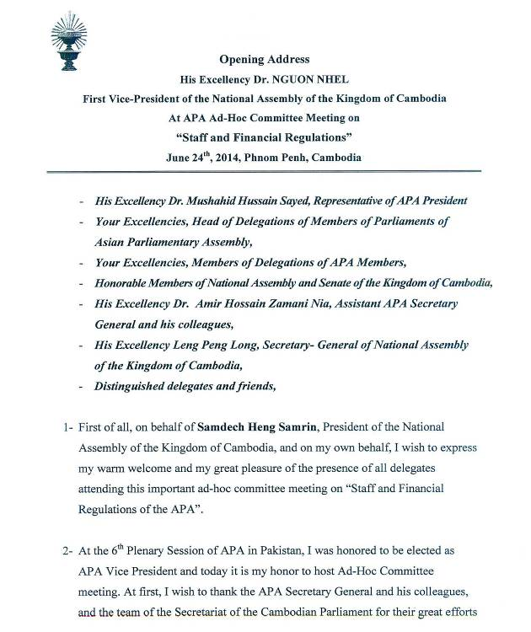
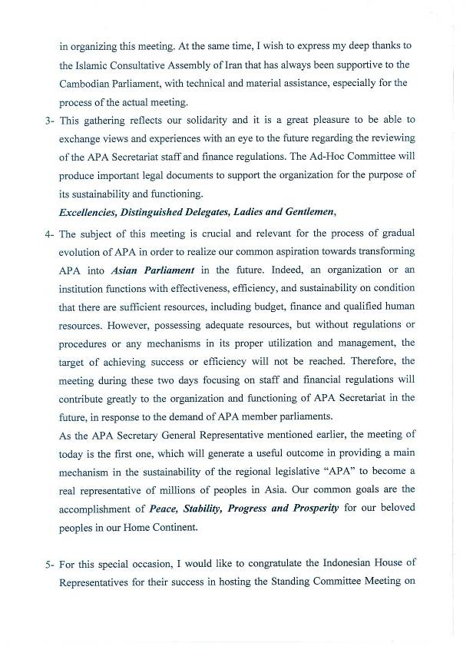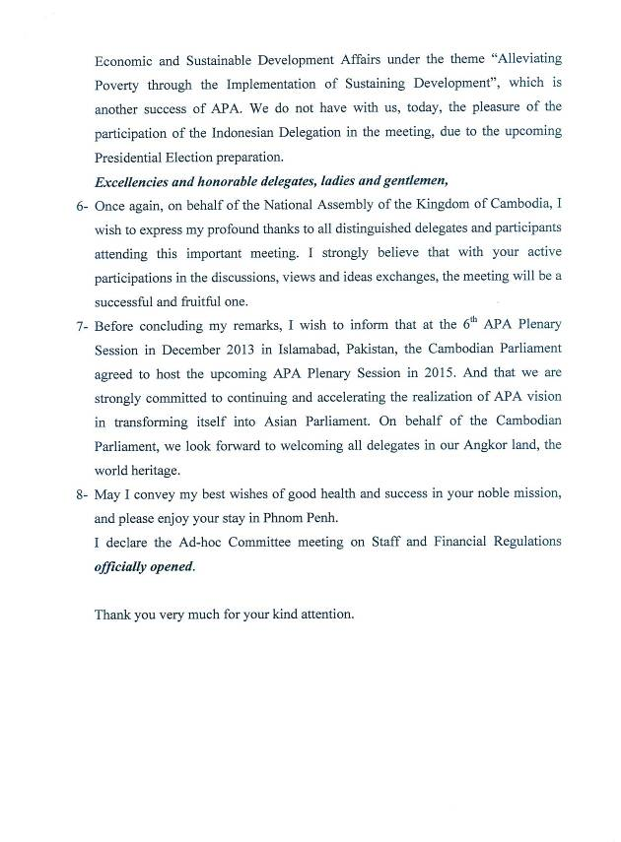
Annex – IV
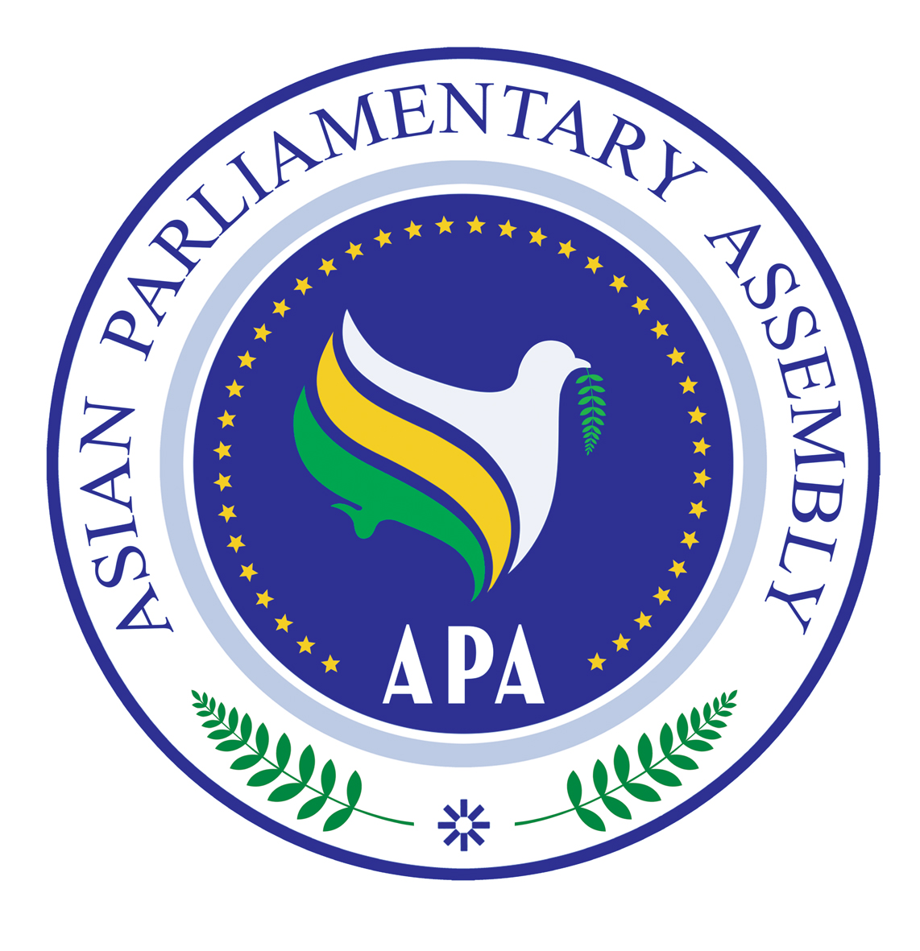

ASIAN PARLIAMENTARY ASSEMBLY
AD-HOC COMMITTEE MEETING ON FINANCIAL AND STAFF REGULATIONS

23-26 June 2014
Phnom Penh-Kingdom of Cambodia

Agenda
Opening Ceremony:

- Welcome Speech by His Excellency Mr. Leng Peng Long, Secretary-General of National Assembly of the Kingdom of Cambodia,
- Remarks by His Excellency Dr. Zamaninia ,APA Assistant Secretary- General,
- Remarks by Honorable Senator Mushahid Hussain Sayed, Representative of APA President,
- Opening address by His Excellency Dr. Nguon Nhel, First Vice – President of National Assembly of the Kingdom of Cambodia.

Ad hoc Committee meeting:
- Adoption of the Agenda and Program of Work
- Election of Bureau
- Statement of the Chairman
- Introduction of Delegations
- Oral report by H. E. Dr. Zamaninia ,APA Assistant Secretary- General,
- Discussion of:
- APA Financial Regulations
- APA Staff Regulations

- Adoption of the final report of the Ad- hoc Committee meeting
- Any other matters
- Closing

